Teeth whitening kit

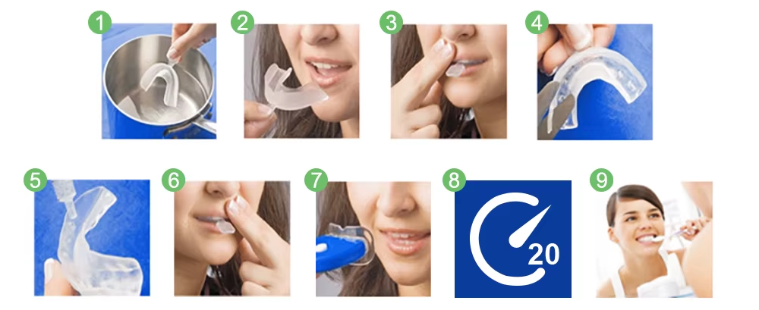

Figure 1, 2 & 3 belong to: 1. Mould
Figure 4 belongs to: 2. Trim
Figure 5, 6, 7, 8 & 9 belong to: 3. Whiten

1. Mould

Mould the thermoplastic mouth trays

Bring approximately four inches of water to a boil, then remove from heat and let it stand for 6–7 minutes.

Submerge one of the mouth trays in the hot water for 10–12 seconds, or until the tray begins to soften. Be careful not to overheat the trays.

Place the mouth tray into your mouth, covering your upper teeth.

Close your mouth and gently suck out all air and excess water to create suction between the tray and your teeth.

Using your fingers, press your upper lip against your teeth to help shape the surrounding tray.

Wait 10–15 seconds, then remove the tray from your mouth.

Submerge the tray completely in a cup of cold water for 10 seconds to help it retain its shape.

Repeat the process for the lower mouth tray.

2. Trim

Trim the mouth trays to the correct height

After molding both trays, use scissors to trim away any excess plastic from the open end of the trays (the part that reaches your gum line).

Trimming the trays at the gum line helps prevent irritation caused by friction or rubbing against this sensitive area.

3. Whiten

Fill the mouth trays and whiten your teeth

Place a small drop of whitening gel in each tooth impression on both the upper and lower trays. Do not overload the trays—less is more.

Insert the trays into your mouth and adjust them so that your teeth fit snugly into the impressions.

Apply gentle pressure to the upper tray by pressing your upper lip with your fingers to ensure a secure fit.

Turn on the LED light by pressing the white button, then hold it as close to your teeth as possible for the duration of the whitening treatment. The LED accelerator is designed to help you achieve better results in less time.

Wear the trays for approximately 20–45 minutes. We recommend starting with 20-minute sessions and gradually increasing the duration as your teeth become accustomed to the process.

After use, remove the trays and rinse them in lukewarm water. Store them in the case provided.

After each treatment, gently wipe away any excess gel from your teeth or gums with a toothbrush to reduce the risk of irritation. Be sure to rinse the toothbrush thoroughly afterward.

(Optional) Mouth spray can freshen your breath. Hold the pump close to your mouth and aim the nozzle toward the side of your cheek or under your tongue. Press down once. If cravings do not ease within a few minutes, use a second spray.

Repeat the treatment weekly until you achieve your desired shade of white.

Range of Application

Effective on stains caused by coffee, tobacco, genetics, tetracycline, food coloring, aging, and other factors that discolor teeth.

Storage

Keep in a cool place and avoid direct sunlight.

Shelf Life

24 months.

Note

Molding and trimming the trays to fit your teeth properly is the most important step. The gel is only effective with well-fitted trays. Poorly molded trays may cause gum irritation or burning, and the whitening results will be reduced. If gum irritation occurs, the discomfort should subside within 24–48 hours.

Warnings

For external use only. Do not swallow.

This product is not suitable for persons under 16 years of age.

Do not use if you have sores, gum problems, cavities, receding gums, or other dental or oral issues.

Not suitable for pregnant or breastfeeding women.

Do not use the product longer than recommended. Do not exceed the maximum treatment time of 45 minutes per session.

If sensitivity or pain persists, discontinue treatment immediately and consult a dentist.

Keep out of reach of children.

